NFE Team's Product Usage Guide

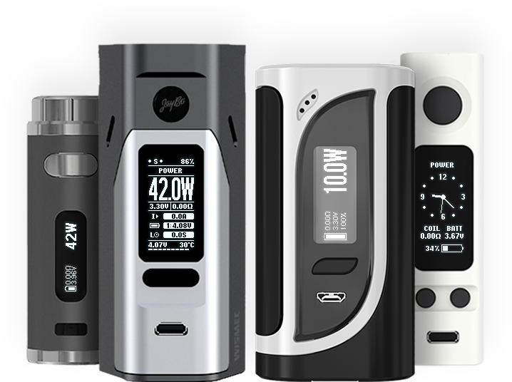
nfeteam.org
Content:
1. Introduction 2
1.1 Main differences of ArcticFox 2
1.2 Technical limitations 3
2. Supported devices 4
2.1 Version compatibility 6
3. Installation 7
4. description of the main features 10
4.1 Profiles 10
4.1.1 Prehit 10
4.1.2 Temperature control 10
4.1.3. PI controller 10
4.2 Smart 11
4.2.1 Lazy mode 11
4.2.2 Smart preheat mode 11
4.3 Topics 12
4.4 Hours 13
4.5. Power Bank 13
4.6 Stealth mode 14
5. NToolbox 15
6. ArcticFox 16
6.1 Main menu 16
6.2 Active profile menu 16
6.3 Screen setup menu 16
6.4 Basic settings menu 17
6.4.1 Advanced settings 18
7. Addressing common problems 20
7.1 BVO 20
7.2 Battery charging current limitation 20
7.3 Restore in Safe Mode 20
7.4 Rollback to factory firmware 21
7.5 Board version failure 21
7.6 Extended error statuses 21
7.7. Force PID 22
8. Authors 23
8.1 Acknowledgements 23
8.2 Project Support 23

1. Introduction
⚠ | REMOVING BATTERIES DURING CHARGING
⚠ | Never remove the batteries or open the hinged cover while the device is charging or connected to a computer. This is very likely to burn out several chips that are responsible for powering the screen, the transistor drivers of the DC-DC converter output transistors, and the charging module.

🛈 | DISCLAIMER
🛈 | The firmware is distributed in the hope that it will be useful. It is distributed as-is without warranty of any kind. You assume all responsibility for installation and use.

ArcticFox is a third-party firmware from NFE Team for Joyetech, Eleaf, Wismec mods and co-branded devices.
NFE Tools is a set of utilities for flexible firmware customization, editing and updating. The set includes:
- NToolbox is a program to monitor, update and configure ArcticFox firmware.
- NFirmwareEditor is a program for editing and updating firmware.

1.1 Main differences of ArcticFox
- Atomizer resistance: 0.05 - 3.5 Ω;
- 8 fully customizable profiles;
- Smart mode - automatic profile switching by resistance;
- Customizable profile modes:
  - VW - Variwatt mode, the atomizer is supplied with constant or pre-hit preset power;
  - TCR - thermocontrol mode according to the set temperature coefficient;
  - TFR - thermocontrol mode according to the set temperature curve;
- Preheating;
- Power Bank - use the mod as a power source (2.1A limit);
- PI controller;
- Hours;
- Customizable battery discharge curves;
- Home screen themes with customizable output in infolines;
- Configuring the event delay time and screen fade out;
- Reassign all button actions and button combinations.

1.2 Technical Limitations
- The minimum resistance of the atomizer is 0.05 Ω;
- Output power (depending on the device);
- Maximum charging current (depending on the device);
- Maximum output current (depending on the device);
- Output voltage range (depending on the device);
- Maximum current in Power Bank mode 2.1 A.
"Device-specific" means that each device has its own values, which are set by the manufacturer. You can find the exact values on the product page of the manufacturer's website.

2. Supported devices
ArcticFox - Main Nuvoton Branch
Joyetech: | Eleaf: | Wismec: | Cobranding:
eVic VTC Mini | Aster | Reuleaux RX75 | VF Lite
eVic VTC Dual | iStick Pico 75W | Reuleaux RX mini | VF Stout
eVic VTwo Mini | iStick Pico 25 | Reuleaux RX200 | VF Classic
eVic VTwo | iStick Pico 21700 | Reuleaux RX200S | BV Centurion
eVic AIO | iStick Pico Mega 80W | Reuleaux RX2/3 | La Petite Box
eVic Basic | iStick Pico Dual | Reuleaux RX GEN3 | VS Switchbox
eVic Primo | iStick Pico RDTA | Reuleaux RX2 20700 | Twisp Vega
eVic Primo 2.0 | iStick iPower 80W | Reuleaux RX2 21700 | Twisp Vega Mini
eVic Primo Mini | iStick TC100W | Reuleaux RX300 | MyVapors myTri
eVic Primo SE | iStick TC200W | Predator 228
Cuboid Mini | iStick QC 200W | Presa TC75W
Cuboid | iStick Tria | Presa TC100W
Cuboid 200 | iKonn 220 | Sinuous P80
eGrip II | Invoke | RX GEN3 Dual
eGrip II Light | iStick Pico S | CB-80
Elitar Pipe | Pico Squeeze 2 | Active
eVic Primo Fit | Aster RT | Luxotic DF
Ultex T80 | iKuu i80 | Luxotic MF
 | Lexicon | Sinuous V80
 |  | Sinuous V200
 |  | ES300

ArcticFox - STM32 Branch
Joyetech: | Eleaf: | Wismec: | Co-branding:
 | iStick Pico X | Sinuous V80
 | iStick Rim | Sinuous V200
 | iStick Rim C | R80

RedPanda
Joyetech: | Eleaf: | Wismec: | Co-branding:
Espion |  | Ravage230
Cuboid Lite
EKEE

The builds are available in the Nightly branch

2.1 Version compatibility
NFE Tools and ArcticFox are related products that are published separately. Version compatibility is determined by the same protocol versions.
The latest builds of NFE Tools and ArcticFox are published on the forum and have a name like [PXX] {Product} {Version}, where
- PXX - P stands for protocol, XX stands for protocol version, for example: P10;
- The product is ArcticFox or NFE Tools;
- The version is GGMMDD, for example: 170822.

3. Installation
Download the latest firmware versions of ArcticFox and NFE Tools, in the respective sections on the official forum:
- ArcticFox;
- RedPanda;
- NFE Tools.

NFE Tools System Requirements:
- Windows XP and above;
- .NET Framework 4.0 or higher.

Installation:
The installation process is very simple and does not require any special knowledge and skills.
- Unpack the archive with NFE Tools.
- Connect your device to PC via USB cable.
- Run NToolbox.exe. In the opened window, optionally select Russian language and click "Firmware Update":
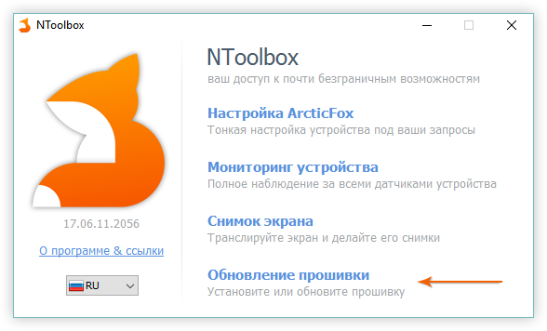
- The firmware update window will appear, you need to click the big "Update" button:
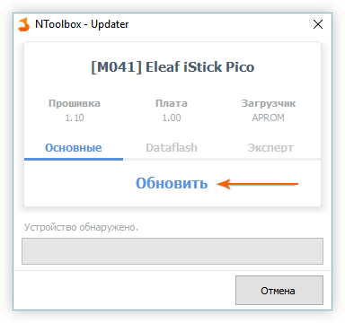
- Select the previously downloaded .bin file with the ArcticFox firmware:
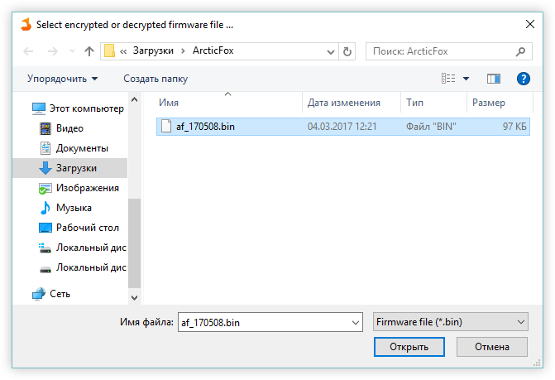
- The firmware installation process will start immediately:
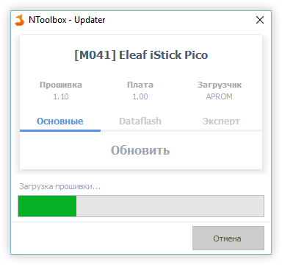
- After a few seconds, you will see a notification that the firmware has been successfully installed:
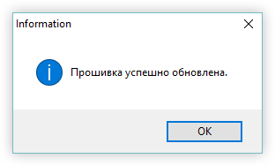
- Your device is flashed and ready to go, great job! ;)

4. description of the main features

4.1 Profiles
We have abandoned the implementation of "modes" and replaced them with profiles. A profile is a set of settings for working with the atomizer, including presets for coil material and resistance, power, temperature, thermocontrol and prehit parameters. There are 8 profiles available to the user, which can be customized using NToolbox. Preset profiles are named PROFILE1..PROFILE8, the first 5 fully correspond to the modes of original Joyetech firmware.
- Click 3 times (default) to select the desired profile.
To edit the active profile:
- Hold down + to call up the main menu and press .

4.1.1 Prehit
Prehit is an increase in the power delivered to the atomizer in the first few seconds. It is used to warm up complex coils faster.
Can be set as time and installed power or percentage of power. A more advanced setting is also available: a graph of power versus time.
Prehit Delay - used for increased heating of the coil during the first puff. The next power increase will occur after the set time has elapsed.
Enabled prehit is warned by the letter "P", if the indicator is blinking - this means that the prehit delay is currently enabled.

4.1.2 Temperature control
13 coil materials are available: VW - for working with disabled thermocontrol (normal varivatt mode), Ni, Ti, SS, TCR - standard Joyetech materials, and 8 pre-tuned TFR materials, which can be downloaded from CSV files from steam-engine.org.
Thermocontrol mode works in the same way as in the Joyetech firmware: you need to select the coil material, if you don't have it, set TCR or import TFR graph. After that, you need to spin the atomizer at room temperature (20 °C) and lock the resistance. There are two ways to lock the resistance:
- Set the resistance lock to the button combination in NToolbox;
- If a normal resistance is displayed on the main screen in the infoline, activate the edit mode of the main screen (4 clicks by default), select the resistance with the button and by clicking on or , switch the lock.
You can reset or edit the saved profile resistance in two ways:
- Go to menu → profile settings → Coil and edit manually, or press , which will force resistance override (or reset if no atomizer is installed);
- To reset, enter profile selection mode and press + (for eVic VTC/VTwo you can reassign the button combination in NToolbox).
Note: TCR factor for SS changed from 120 to 92.

4.1.3. PI controller
To improve power and temperature stabilization in thermocontrol mode, the firmware implements a full-fledged PI controller. The detailed principles of its operation can be found in Google, as their description will take a couple of three pages. In simplified understanding, the PI-regulator has the following settings:
- Range - the temperature at which the regulator is turned on. 0 - it is always on and regulates the power from the beginning of puffing. 20% - the regulator will turn on when it reaches twenty percent of the set temperature in the profile.
- P is a proportional constant, the higher the value, the more the power adjustment changes. For example, on simple spirals it is better to increase the value, because they lose temperature quickly, unlike more weighty spirals.
- I - integral constant; responsible for smoothing the power control peaks.

4.2 Smart
Profile switching is possible both in manual mode and in automatic mode - based on stored resistances, with a customizable tolerance for determining compliance. All you need to use automatic switching is to activate the "Smart" mode and assign the corresponding profiles to the atomizers by screwing them on one by one. You can also prepare a profile in advance using NToolbox.
When you install the atomizer later, the profile saved for it will be selected automatically. If no matches are found in the profiles when defining the atomizer, you will be prompted to assign a new profile/edit the current profile.
When selecting a profile manually, if there is a resistance mismatch, you will be prompted to confirm whether to update or save the selected profile.

4.2.1 Lazy mode
The "Smart" mode of operation, in which profile switching only takes place when the atomizer is changed and only when the active device is turned on. If you change the atomizer while sleeping or loading the configuration from NToolbox, the profile will not be switched automatically.

4.2.2 Smart preheat mode
The Smart Preheat feature intelligently modulates the preheat power based on the time interval between consecutive puffs. This provides a consistent experience by reducing the preheat intensity when puffs are taken in rapid succession.
Key Parameters:
Power: The base operating power (P).
Preheat (%): The initial power boost, expressed as a percentage of the base power (PP).
Preheat Time: The duration for which the preheat power is applied (TP).
Preheat Delay: The cooldown period after a puff, after which the preheat will activate at full intensity again (TD).
Standard Preheat Operation:
In the standard mode, preheat activates at the set percentage only if the time since the last puff (T) exceeds the configured Preheat Delay (TD).
If T ≥ TD: Preheat activates at full power (P * PP).
If T < TD: Preheat does not activate; the coil is heated at the base power (P).

Smart Preheat Operation:
When Smart Preheat is enabled, the preheat power is dynamically calculated if a new puff is initiated before the Preheat Delay has fully elapsed. The intensity scales linearly with the time that has passed.
The formula for calculating the Smart Preheat power (PSP) is:
PSP = PP * (T / TD)
Where:
PSP is the resulting preheat percentage used for the new puff.
PP is the configured Preheat (%).
T is the actual time since the last puff.
TD is the configured Preheat Delay.
Example Configuration:
Power (P) = 20 W
Preheat (PP) = 150%
Preheat Time (TP) = 1.0 s
Preheat Delay (TD) = 10 s
Operation Example:
First Puff: The preheat activates at full intensity. Power for the first second is 20 W * 150% = 30 W.
Second Puff after 5 seconds (T):
Since T (5 s) < TD (10 s), Smart Preheat engages.
The effective preheat percentage is calculated: 150% * (5 s / 10 s) = 75%.
The resulting power for the first second of this puff is 20 W * 75% = 15 W.
Third Puff after 15 seconds (T):
Since T (15 s) ≥ TD (10 s), preheat activates at the full configured 150%. Power for the first second is 30 W.

If no matches are found for the time-based adjustment, the preheat will operate at its standard configured values. When manually adjusting preheat settings, you will be prompted to confirm or save the changes to the active profile.

4.3 Themes
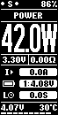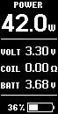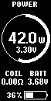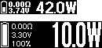
The firmware provides three home screen themes to choose from: Foxy, Classic and Round. For smaller screens, you can customize the font thickness of the infolines.
Editing the main screen is different from the original Joyetech firmware. To edit infolines on the main screen, call the "edit main screen" action (by default 4 clicks with button). A single click with the button will switch to the next editable item. The selected item is edited with the buttons / . To exit the editing mode, hold down the button for about 1 second. You can also customize the main screen in NToolbox.
Note: To reset the steam meter, select it in the infoline and hold + .

4.4 Hours
The firmware supports timing with and without hardware support. For more convenient use, you can enable time synchronization of the mod with your computer. To do this, right-click on the NToolbox icon in the tray (near the clock) and check "Synchronize time when device is connected".
The watch can be operated in three timing modes:
LXT - RTC mode for mods with built-in quartz resonator 32768 Hz.
LIRC - default RTC mode for mods without built-in quartz resonator. Time in sleep mode will be controlled by the internal LIRC oscillator. Due to the strong noise of the oscillator, the timing will be inaccurate. However, you can adjust the average frequency (LIRC Speed) in Settings → Clock. The value will be unique for each mode.
Selection method: lower the value by 100, leave the mod for 30 minutes, then compare the time. Selection of the optimal value is possible only by trial and error, but still will not guarantee an accurate clock. It is also possible to enable LSL mode, then frequency adjustment will not be required.
LSL (Light Sleep Mode) is a light sleep mode. When the device is turned off, it goes to sleep, but not completely. The central processor remains on, which ensures correct clock running, while the battery is discharged by about 0.1-0.2 volts per day on single-battery devices. At all other settings, the clock has no effect on power consumption. The enabled LSL mode is warned by a "!" next to the battery or the letter "L" in the foxy theme.
Note: after switching the RTC mode, disconnect the USB and reboot your mod by removing the batteries for about 30 seconds. If you fail to start the RTC module in LXT mode, the mode will automatically switch to LIRC/LSL, which may indicate a hardware problem or a missing crystal resonator on your mod's board.
Warning: in LSL mode, the battery over-discharge protection does not work and the voltage may drop below the permissible threshold. Keep an eye on battery discharge yourself if you leave the box in standby mode for a long time with LSL enabled. We recommend removing the batteries if you do not use the mod for several days.

4.5. Power Bank
Supports Avatar RC adapter and similar. Provides chargeable devices with 5 V voltage (adjustable up to 5.25 V, see § 6.4.1.) and current up to 2.1 A. To start charging, open this item in the main menu, place the RC adapter on the mod, connect the device and press . Power Bank mode has a function of automatic shutdown when the supplied current does not exceed 50 mA (indicated by blinking "On").
To turn off the screen while charging, press .
To stop charging, press .
To exit Power Bank mode, press and hold the button or the
and at the same time.

4.6 Stealth mode
Supported box mods use LED displays, which are prone to burn-in. To minimize pixel burn-in, the firmware implements stealth mode. It is activated by holding + button combination (by default, can be reassigned using NToolbox). When stealth mode is active, the screen is off by default. To turn the screen on, click . During the next long press of (puff) or when the fade delay expires, the screen will turn off again. Also, by default, the charging screen and screen saver are not displayed in stealth mode, but can be enabled in the "Stealth" section of the screen settings or in a similar section in NToolbox.
Note: in box mods with separate LED indicators (eGrip II/Light, eVic AIO, Pico RDTA, Sinuous P80), the backlight is off in stealth mode.

5. NToolbox
NToolbox is a utility included in the NFE Tools package. Provides a wide range of possibilities to configure and monitor the box mod from a computer. It is divided into 4 main components:
- ArcticFox Settings is a configurator that allows you to fully customize your box mod from your computer, as well as reset settings or save them backed up in a configuration file. Some settings are available only in NToolbox.
- Device monitoring - tracks all sensors of the box mod in real time. Allows you to record sensor readings and save them as a .csv table.
- Screenshot - broadcast the box mod screen to your computer, create screenshots.
- Firmware Update - used to update the device software. Also shows the software and board version, allows to reset and write Dataflash.
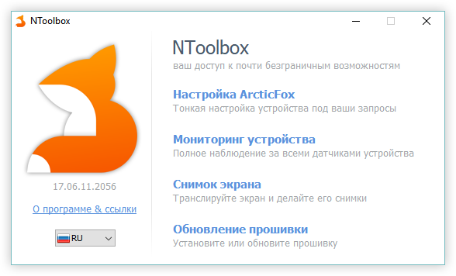
Example of the NToolbox main window.

6. ArcticFox
Third-party firmware developed by NFE Team. Currently supports 55 box mods running on Joyetech and its subsidiaries. The firmware is created with the idea of safe use of box mod with its maximum control. Provides a wide range of simple and complex customization options:

6.1 Main menu
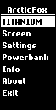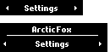
Hold down + (default) for 1 second to open the menu.
To return to the previous menu section, hold + or + .

6.2 Active profile menu
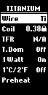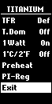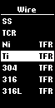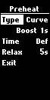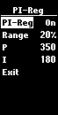
- Wire - the material of the spiral;
- Coil - Stored Resistance;
- TCR - adjust TCR of the material when using a non-standard material;
- T. Dom - adjust the temperature on the main screen;
- 1 Watt is the power adjustment step without tenths;
- 1°C/2°F - temperature adjustment step;
- Preheat - Preheat settings;
- PI-Reg - PI controller for thermocontrol mode, improved power and temperature stabilization.

6.3 Screen setup menu
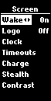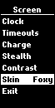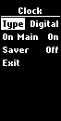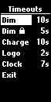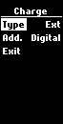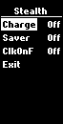
- Wake 🢐 🢒 - wake up the mod with the adjustment buttons / ;
- Logo - displays a custom logo on the Home screen;
- Clock
  - Type - analog or digital;
  - On Main - displays the clock on the main screen;
  - Saver - time of displaying the screen saver clock in the standby mode;
- Timeouts
  - Dim - time of automatic screen fading;
  - Dim - time of automatic screen fading in locked state;
  - Charge - time of automatic fading of the charging screen, 0 - always on (the screen can be displayed when you press or );
  - Logo - the delay time before the logo is displayed;
  - Clock - the delay time before the clock is displayed;
- Charge
  - Type - type of charging screen: standard or with additional information;
  - Add. - add-ons: clock or logo;
- Stealth - screen settings in stealth mode:
  - Charge - display the charging screen in stealth mode;
  - Saver - display the screensaver in stealth mode;
  - ClkOnF - show the clock by single click of the button if it is enabled on the main screen;
- Contrast - adjusts the brightness of the display;
- Skin - select a theme for the Home screen.

6.4 Basic settings menu
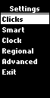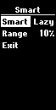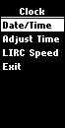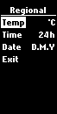
- Puffs - counter settings:
  - Counters - display of statistics;
  - RCOBC - Reset Counters on Battery Change, reset statistics on battery change;
  - Cutoff - maximum puffing time;
  - Session - session: record puffs and vaporization time while the device is active, or limit on "smoke breaks";
  - Limit - maximum number of puffs or vaporization time before the device locks/unlocks (depending on the 5 Clicks setting), to change units hold ;
- Clicks - customize the actions of quick clicks
  - 2/3/4 times:
    - None - not assigned;
    - Main Menu - menu call, double of pressing + ;
    - Edit Main - Edit the main screen, the equivalent of 3 Joyetech clicks;
    - Preheat - setting of preheating in the current profile;
    - Edit Profile - built-in editor of the current profile;
    - Profiles - profile selection screen;
    - Reset Cnt. - display the statistics screen with the option to reset counters;
    - T. Dom - switches primary regulation of the current profile (power/temperature);
    - Coil - on/off resistance lock (for TC);
    - Coil - re-read the resistance of the atomizer;
    - Smart - forcibly override the atomizer with a Smart call;
    - Clock - display/hide the clock on the main screen;
    - Info - Display the summary screen;
    - Bank - switches the mod to Power Bank mode;
    - Stealth - on/off stealth mode;
    - Smart - enable/disable the Smart mode;
    - LSL - Light Sleep mode on/off;
    - Key - enable/disable locking of buttons and ;
    - Device - enable/disable mod lock (all buttons are locked, but the mod remains enabled);
    - On/Off - enable/disable the mod;
  - 5 times:
    - On/Off - enable/disable the mod;
    - Device - lock all buttons, but leave the mod enabled;
- Smart - setting of automatic switching of profiles:
  - Off/On/Lazy - sets the behavior of Smart mode;
  - Range - range of resistance definition;
- Clock - setting of the real time clock:
  - Date/Time - sets the current date and time;
  - Adjust Time - fine adjust the time in 1 second increments;
  - LIRC Speed - adjusts the speed of the internal inaccurate oscillator used in mods without an external 32768 Hz quartz resonator on the board;
- Regional - settings of regional parameters:
  - Temp - displays the temperature in Celsius (°C) or Fahrenheit (°F);
  - Time - displays the time in 24-hour or 12-hour format;
  - Date - display calendar date in the format number.month.Year or month/number/year;

6.4.1 Advanced settings
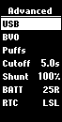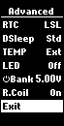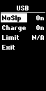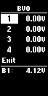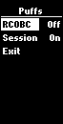
Advanced - a section of fine-tuning settings for advanced users:
- USB - setting the charging behavior of the mod:
  - NoSlp - prohibition of going to sleep at the end of charging if USB is connected;
  - Charge - charging batteries from USB, only for multi-battery mods;
  - Limit - charging current limitation (N/A - the mod hardware does not support charging control);
- BVO - mod voltmeter correction - tweak battery voltage measurement;
- Shunt - correction of the measuring shunt value - adjusting the ohmmeter of the mod for more accurate readings;
- BATT - battery discharge curve, used for more accurate display of % charge;
- RTC - selection of the real time clock mode;
- DSleep - deep sleep setting (transition after 3 minutes of inactivity by default, delay can be set with NToolbox):
  - Std - normal deep sleep;
  - - before going into deep sleep, the mod is switched to the "off" state;
  - - The mod is additionally locked before going into deep sleep;
- TEMP - board temperature sensor, Ext - external (thermistor), Int - embedded (microcontroller);
- LED - enable backlighting in eGrip II/Light, eVic AIO, Pico RDTA, Sinuous P80 mods;
- Bank - voltage supplied in Power Bank mode;
- R.Coil - displays the last measured resistance of the atomizer on the standby screen, On = last measured resistance, Off = measured when the atomizer is installed as before.

7. Addressing common problems

7.1 BVO
Some box mods have problems with inaccurate battery voltage measurement. To correct the read voltage, a correction option for the box mod's voltmeter - BVO (Battery Voltage Offset) - has been introduced.
For example, you have noticed that when charging the batteries in the boxmod, there is an unbalance: one bank has a voltage at 100% of 4.05V and the other bank has a voltage of 4.10V.
However, when measuring the voltage with a tester or in an external charger, both batteries have the same voltage of 4.05V and 4.05V respectively.
In this case, BVO correction is necessary. Charge the batteries in an external charger, it is very desirable that they were identical, "married", it will facilitate calibration. Measure the voltage on the batteries with a tester, set them in the mod and, by correcting the BVO, achieve correct readings in the monitor or on the information screen.
Note: Many mods have a non-linear ADC characteristic, which results in noticeable differences in the correctness of measurements depending on voltage. Select the correct battery voltage when calibrating:
- if you are charging batteries in the mod, calibrate the BVO with fully charged batteries (ideally freshly removed from an external charger at the end of a full charge);
- If you want to maximize battery capacity, calibrate the BVO at 3.3..3.5 volts.

7.2 Battery charging current limitation
The firmware implements the ability to adjust the battery charging current to avoid excessive heating of the mod and to protect the external power supply from overloading. This setting works only on multi-battery mods and Pico 25.
The input current is adjusted in the Advanced section of the firmware settings or in the NToolbox.
Note: changes will only take effect the next time you connect USB or start charging.

7.3 Restore in Safe Mode
Safe mode boots your device into recovery mode, which is used to recover from a failed firmware installation and verify that the device is working properly. More specifically, it is the boot loader that is used to load the firmware. Each device has its own boot loader, which is not changed during firmware installation.
Starting Safe Mode:
- Disconnect the USB cable if it is connected before;
- If the device runs on replaceable batteries:
  - Remove all batteries from the device;
  - press and hold the button on the device;
  - connect the device to a PC;
- If the device has a built-in battery:
  - connect the device to a PC;
  - press and hold the button on the device;
  - briefly press the Reset button on the device (see the user manual for the device);
- You can now release the button .
If you have done everything correctly, your device is in safe mode.
How do I know if the device is in safe mode?
- The screen is off;
- The device does not respond to button presses;
- The device is detected by the PC;
- The firmware version is displayed as "0.00";
- If you are using NToolbox - Firmware Upgrade, the boot mode will be LDROM.

7.4 Rollback to factory firmware
To rollback to factory firmware you need to download the firmware binary file from your boxmod manufacturer's website and update the boxmod using NToolbox.

7.5 Board version failure
In very rare cases, the board version may be reset due to a failure in the device update process. As a result, the box mod may not have a working screen or may fail during subsequent updates. To fix the board version, you need to launch NToolbox, go to the firmware update and set your board version in the "Expert" tab.

7.6 Extended error statuses
The "Atomizer Low /x/" and "Atomizer Short /x/" messages have additional statuses (x is the error code) that will help you solve some problems on your own or facilitate diagnosis.
Atomizer Low" error codes:
- 0 - atomizer is detected, but resistance is below 0.05 ohm, occurs when button is pressed in standby mode;
- L - resistance dropped below 0.05 ohms during the tightening process.
Atomizer Short" error codes:
- E - atomizer current is exceeded. It can appear in case of incorrectly measured (overestimated) resistance when screwing on the atomizer, as well as in case of hardware problems (poor quality connections of the power part, insufficiently good fixing of the coil, etc.). One of the symptoms leading to this error is that the displayed resistance of the atomizer drops when you press and rises in standby mode;
- A - current limit exceeded for spirals with resistance below 0.1 ohm, reduce power;
- S - resistance dropped below 0.02 ohms during tightening;
- P - sharp drop in resistance during tightening (measured resistance is lower than the fixed resistance by a factor of 4);
- X - most likely the hardware part of the mod is defective: the resistance cannot be measured correctly at all;
- 0 - occurs when the button is pressed in standby mode - may signal "contact bounce", as the atomizer resistance may be measured correctly, but the corresponding atomizer status is not set.

7.7. Force PID
A very small number of devices are produced by the manufacturer with an incorrect bootloader. In this case NToolBox will detect your device incorrectly. The official firmware contains hardcode to support the specified device and works fine on it. ArcticFox is a universal firmware for many devices and reads the device ID from the bootloader and then decides how to run on the device. If ArcticFox is installed on a device with the wrong bootloader, the device will not work properly or at all. To ensure that ArcticFox firmware can be used even on defective devices, you can override the device identifier (PID).
If your device has the wrong bootloader, you can try changing the PID:
- launch NToolBox -> Firmware Update and hold CTRL + SHIFT + ALT while selecting the firmware file, then a window with PID selection will appear.

8. Authors
Our small but friendly NFE Team:
maelstrom2001
ReikoKitsune
Zinger
ArionWT
You can always find us on the official forum: https://nfeteam.org/forum.

8.1 Acknowledgements
Special thanks goes to ClockSelect for the wonderful myEvic project, which inspired us to create our own firmware and a set of tools to work with it.

8.2 Project Support
If you like our project and would like to support its development, you can donate to us the amount you find acceptable. All details can be found on the official website.

